**15. Section overview**

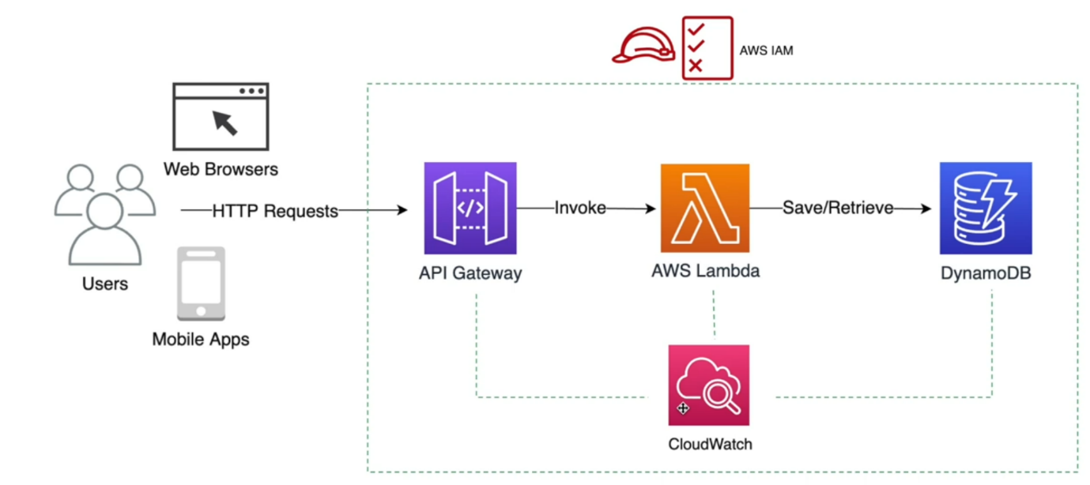

* let me introduce some of the core services that will be using in this course.
* So, let us start by learning about AWB Lambda.
* This is the core service that run code and logics in response to various events.
* It is a serverless service, meaning that we do not have to manage any servers and aws will take care of it and Lambda is even driven.
* A lambda function can be invoked by various events. This includes a http event as well.
* Now these http events such as get, post, delete, put and so on are made by users through web browsers and mobile applications. We commonly use an API to intercept these requests. So here we use Amazon API Gateway.
* Amazon api Gateway is a serverless rest api service. Meaning that we do not have to manage any servers to run our rest api. So, let us learn more about API Gateway and AWS Lambda in this section.
* Now, once API Gateway receives these HTTP requests from users, it invokes lambda functions. Lambda functions from AWS lambda will execute the business logics in response to these http requests.
* Now this business logic can include saving data in a database and we are going to use Amazon Dynamo DB as a Cloud Native Serverless database to save any data from Lambda functions Again, serverless means we do not manage any database servers and Cloud Native means that this Dynamo DB database is built for cloud. It has many integrations with other AWS services such as AWS IAM.
* The Dynamo DB is also a no sql database. It guarantees millisecond latency at any scale. Now in this course you will get hands on experience with the Dynamo DB and if you want to learn more about it, check the Dynamo DB crash course in the bonus section.
* let us talk about AWS IAM, now this is the fundamental AWB service that is used to manage permissions and access control. When one AWS service talks to another AWB service or as users, when we are interacting with AWS services.
* Finally, we are going to learn about Amazon Cloud, which. this is to centralize logging and monitoring. deeply integrated with other aws services.
* So, if you want to inspect logs and matrices of other services, you should probably check cloud watch. So, let us learn more about cloudwatch in this section.